**Riddle of the Hidden Scrolls**

***Crypto***

**Challenge:**

Captain Jack Sparrow, notorious for his cunning wit and love for the sea, intercepted a letter sent by his arch-nemesis, Barbossa.

VUUEV2QGW364QGN3YE:MN16eUGMpaE:La2:VMDty`03>

**Approach:**

I checked it amongst a cipher identifier and it did not give any good results.

Next i did was xor it amongst different numbers up to 20 and i got these:

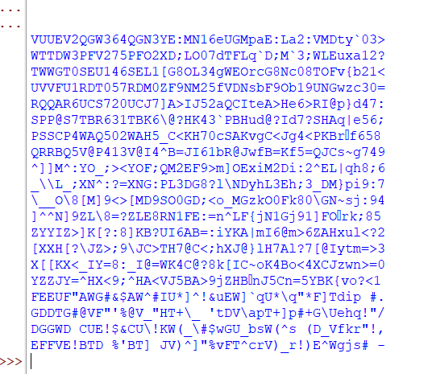

All looked useless until we noticed this string on line 4, it kinda looks like encoding?

Its base64 and we decode it to get:

**Flag: QUESTCON{D34d_M3n_T3ll_No_T4l3s}**

Congrats!!

Happy Hacking!